Short Term International Certificate of Fitness For the Carriage of Dangerous

Chemicals in Bulk
Issued under the provisions of the
INTERNATION CODE FOR THE CONSTRUCTION AND EQUIPMENT OF SHIPS CARRYING DANGEROUS CHEMICALS IN BULK
(Resolutions MSC. 176(79) and MEPC.119 (52))
Under the authority of the Government of

THE MERCHANT MARINE HONDURAS
By GR CLASS CLASSIFIED FOR STANDARD (GR CLASS)

IBC No.:
Name Ship | Distinctive number or letters | Port of registry | Gross tonnage | Ship type  (Code paragraph 2.1.2)
 | {call_sign} | HONDURAS | {gross_tonnage} | {ship_type}
 | IMO number: | HONDURAS
 | {imo_number} | HONDURAS

Date on which keel was laid or on which the ship was at a similar stage of construction or (in the case of a converted ship) date on which conversion to chemical tanker was commenced:

The ship also complies fully with the following amendments to the Code:

The ship is exempted from compliance with the following provisions of the Code:

THIS IS TO CERTIFY:
- That the ship has been surveyed in accordance with the provisions of section 1.5 of the Code.
- That the survey showed that the construction and equipment of the ship and the condition thereof are in all respects satisfactory and that the ship complies with the relevant provisions of the Code:
- That the ship has been provided with a Manual in accordance with Appendix 4 of Annex II of MARPOL 73/78 as called for by regulation 14 of Annex II, and that the arrangements and equipment of the ship prescribed in the Manual are in all respects satisfactory;
- That the ship meets the requirements for the carriage in bulk of the following products, provided that all relevant operational provisions of the Code and Annex II of MARPOL 73/78 are observed:

Products | Conditions of Carriage (tank numbers, etc.) | Pollution Category
Continued on attachment 1, additional signed and dated sheets1
Tank numbers referred to in this list are identified on attachment 2, signed and dated tank plan.
Continued on attachment 1, additional signed and dated sheets1
Tank numbers referred to in this list are identified on attachment 2, signed and dated tank plan.
- That, in accordance whit 1.4 / 2.8.22, he provisions of the Code are modified in respect of the ship in the following manner:

1 Delete as appropriate

2 Delete as appropriate.

- That the ship must be loaded:
- in accordance with the loading conditions provided in the approved loading manual, stamped and dated and signed by a responsible officer of the Administration, or of an organization recognized by the Administration2.
- in accordance with the loading limitations appended to this Certificate2.
Where it is required to load the ship other than in accordance with the above instruction, then the necessary calculations to justify the proposed loading conditions shall be communicated to the certifying Administration who may authorize in writing the adoption of the proposed loading condition3.

This certificate is valid until 4Subject to surveys in accordance with 1.5 of the Code. Completion date of the survey on which this certificate is based(YY/MM/DD):

Issued at Date of Issue

(Place of issue of certificate) (YYYY-MM-DD)

The undersigned declares that he is duly authorized by the said Government to issue this certificate.

Signature of authorized official issuing the certificate

Notes on completion of Certificate:
- The Certificate can be issued only to ships entitled to fly the flags of States which are both a Contracting Government to the 1974 SOLAS Convention and Party to MARPOL 73/78.

- “Ship type”: Any entry under this column must relate to all relevant recommendations, e.g. an entry “Type 2” means Type 2 in all respects prescribed by the Code.

- Products: Products listed in Chapter 17 of the Code, or which have been evaluated by the Administration in accordance with 1.1.6 of the Code, shall be listed. In respect of the latter "new" products, any special requirements provisionally prescribed shall be noted.

- Products The list of products the ship is suitable to carry shall include the Noxious Liquid Substances of Category Z which are not covered by the Code and shall be identified as "Chapter 18 category Z".

IBC No.: IMO No.

3 Instead of being incorporated in the Certificate, this text may be appended to the Certificate if duly signed and stamped.
4 Insert the date of expiry as specified by the Administration in accordance with 1.5.6.1 of the Code. The day and the month of his day correspond to the anniversary date as defined in 1.3.3 of the Code, unless amended in accordance with 1.5.6.8 of the Code.

GR CLASS CLASSIFIED FOR STANDARD (GR CLASS)

INTERNATIONAL CERTIFICATE OF FITNESS FOR THE CARRIAGE OF DANGEROUS CHEMICALS IN BULK

ATTACHMENT No. 1

IBC No.

Continued list of products to those specified in section 4, and their conditions of carriage.

Products | Conditions of Carriage (tank numbers, etc.) | Pollution Category

Place and Date GR Class Representative

GR CLASS CLASSIFIED FOR STANDARD (GR CLASS)
INTERNATIONAL CERTIFICATE OF FITNTESSFOR THE CARRIAGE OF DANGEROUS CHEMICALS IN BULK

ATTACHMENT No. 2

TANK PLAN

IBC No.

Name of ship
Distinctive number or letters:
IMO Number

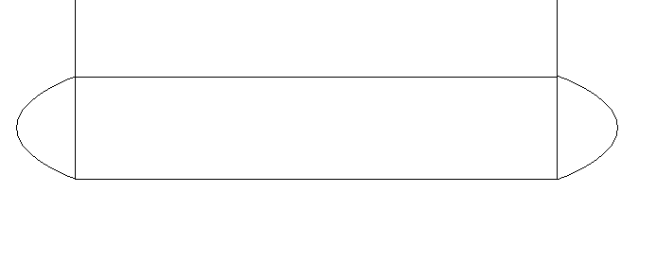
Cargo area

Place and Date GR Class Representative

